Understanding Cross-Validation: How K-Fold Improves Model Evaluation Stability
Student: Vijaya Lasya Sree – ID: 24180156
Github link: https://github.com/Lasyasreeachanta/Cross-Validation_and_K-fold.git
- Introduction
When building a machine learning model, achieving high accuracy on training data is not the ultimate goal. What truly matters is how well the model performs on unseen data—this is known as generalisation. A common beginner mistake is relying on a single train–test split to estimate performance.
This tutorial explores cross-validation (CV) as a more reliable evaluation technique. Using the Breast Cancer Wisconsin dataset from scikit-learn, I:
- Demonstrate how accuracy varies across different random train–test splits
- Apply K-Fold cross-validation to obtain a more dependable estimate
- Investigate how different values of K influence mean accuracy and variability
- Compare Logistic Regression and Random Forest using the same CV setup
The goal is to move beyond blindly trusting cross_val_score and instead develop an intuitive understanding of why cross-validation works.

2. Dataset and Problem Setup
The Breast Cancer Wisconsin dataset contains 569 samples with 30 numerical features derived from tumour images (e.g., radius, texture, smoothness).
Figure 1 shows the class distribution in the dataset.
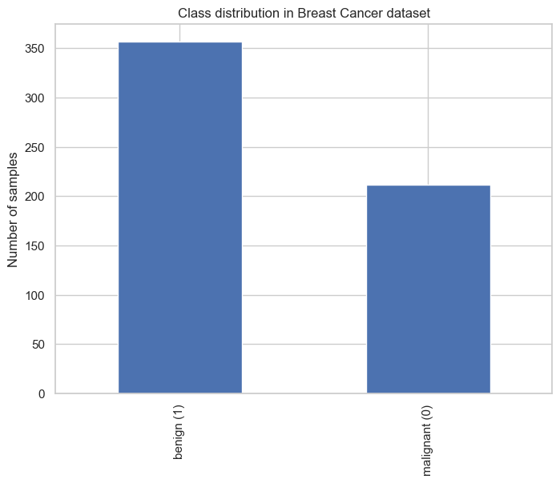
The target variable is binary:
- 0 → malignant
- 1 → benign
The dataset includes 357 benign and 212 malignant cases, making it slightly imbalanced toward benign samples.
All features are used in their original numeric form. For Logistic Regression, feature scaling (zero mean and unit variance) is applied within a scikit-learn Pipeline to ensure stable optimisation and comparable coefficients.

3. Baseline: Single Train–Test Split
3.1 Experimental Design
The baseline follows a standard workflow:
- Split data into 80% training and 20% testing using stratification
- Train a Logistic Regression model with L2 regularisation
- Evaluate accuracy on the test set
For one random split, the model achieved approximately 98.25% accuracy. While impressive, this raises an important question: Is this result consistent across different splits?
3.2 Sensitivity to random splits
To examine this, the experiment was repeated using 10 different random seeds. The resulting table of scores is shown below:
 | Random State | Accuracy
0 | 10 | 0.964912
1 | 15 | 0.991228
2 | 20 | 0.982456
3 | 25 | 0.982456
4 | 30 | 0.982456
5 | 35 | 0.973684
6 | 40 | 1.000000
7 | 45 | 0.964912
8 | 50 | 0.982456
9 | 55 | 0.956140
The observed accuracies ranged from 95.61% to 100%, with most values between 97% and 99%. Figure 2 visualises this variability.
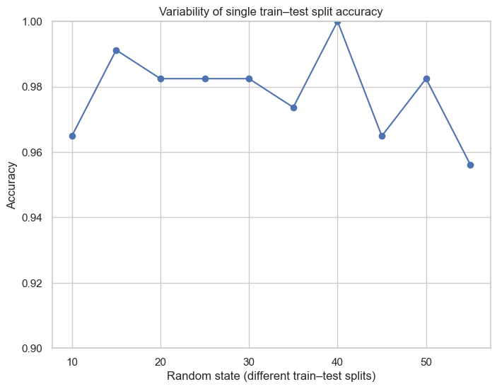
This variation (~4.5%) shows that performance estimates can depend heavily on how the data is split. In sensitive domains like healthcare, such variability can lead to misleading conclusions. This highlights the need for more robust evaluation methods like cross-validation. This is not a trivial issue for a medical setting, where the very same model could get the label of “almost perfect” or “just good enough” depending on the random number generator seed. This is the exact problem that cross-validation aims to mitigate, specifically the problem of variability (Kohavi, 1995).

4. K-Fold Cross-Validation
4.1 Applying 5-Fold CV
In 5-Fold cross-validation:
- The dataset is divided into 5 equal parts
- The model trains on 4 parts and tests on the remaining part
- This process repeats until each fold has been used as the test set
For Logistic Regression, the fold accuracies were:
- 0.9737, 0.9825, 0.9649, 0.9912, 0.9735
The results yield:
- Mean accuracy: 0.9771
- Standard deviation: ~0.009
Figure 3 displays these results as a bar chart.
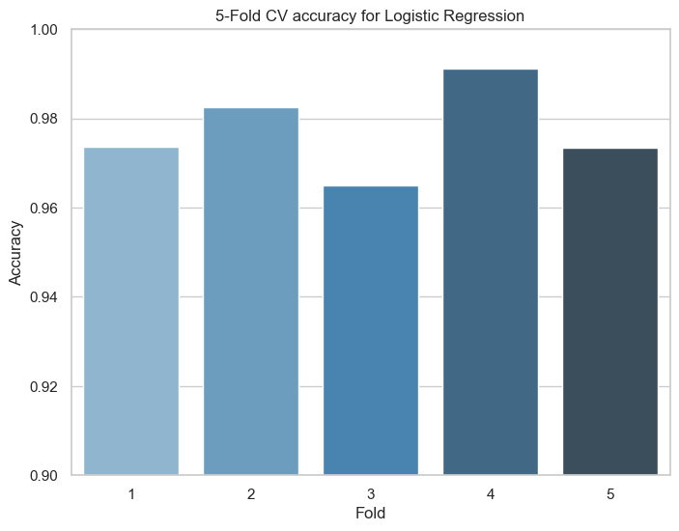
The mean 5-fold accuracy is 0.9771 and the standard deviation is about 0.0090, as summarised in the comparison table between single split and CV:
 | method | mean_accuracy | std_accuracy
0 | single split | 0.982456 | NaN
1 | 5-fold CV | 0.977146 | 0.008964
Key Observations
- The average CV accuracy closely matches the typical single-split results
- CV provides additional insight through variance, indicating performance stability
- The small standard deviation (~1%) suggests consistent performance across subsets
This supports the idea that K-Fold CV provides a more reliable estimate than a single hold-out split. (Hastie, Tibshirani and Friedman, 2009).

5. Effect of the Number of Folds $K$
Cross-validation has a hyperparameter of its own: the number of folds $K$. To explore its effect, I repeated the Logistic Regression CV experiment with K = 3, 5, 10.
The results were:
- $K=3$: mean accuracy ≈ 0.9734, std ≈ 0.0076
- $K=5$: mean accuracy ≈ 0.9771, std ≈ 0.0090
- $K=10$: mean accuracy ≈ 0.9753, std ≈ 0.0195
Figure 4 plots mean accuracy versus $K$, and Figure 5 plots the standard deviation versus $K$.
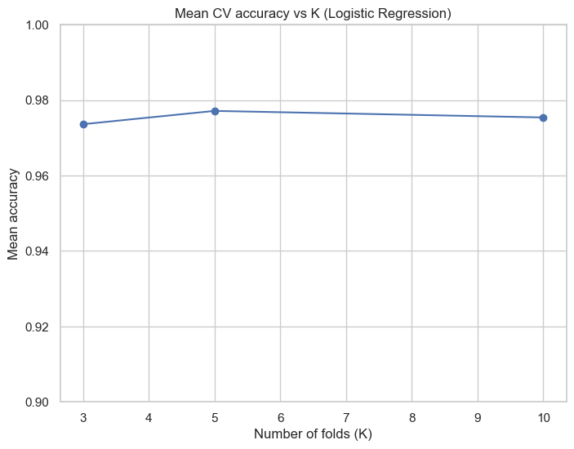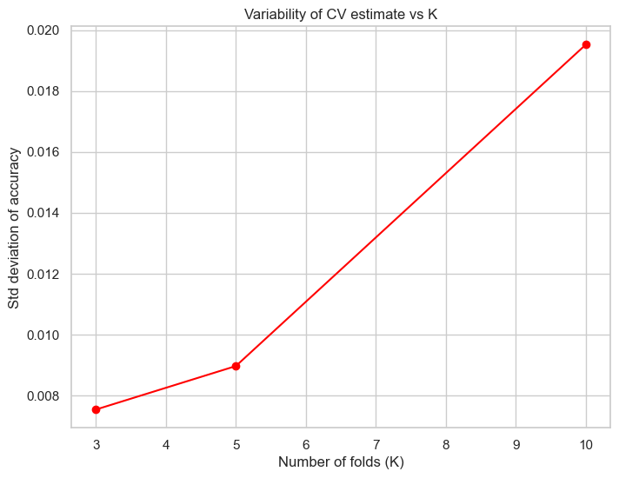
The findings are:
- Mean accuracy is stable. All three values are within about 0.004 of each other. This suggests that, for this dataset, the choice of $K$does not drastically change the estimated level of performance.
- Variance behaviour is nuanced. In theory, increasing $K$trades bias for variance: higher $K$uses larger training sets but more correlated folds, which can slightly increase the variance of the estimate (Kohavi, 1995). In the results, $K=10$indeed shows the largest standard deviation (~0.0195). Given our moderate sample size (569 cases), very small validation folds in 10-fold CV may be more sensitive to which specific patients are held out.
In practice, 5-fold CV offers a good balance between computational efficiency and stability.
6. Model Comparison Using Cross-Validation
Cross-validation is particularly useful when comparing models fairly. Here, two models were evaluated:
- Logistic Regression (with scaling)
- Random Forest (200 trees)
Both used the same 5-fold splits.
6.1 Fold-wise scores
The fold-wise accuracies were:
- Logistic Regression: 0.9737, 0.9825, 0.9649, 0.9912, 0.9735
- Random Forest: 0.9649, 0.9737, 0.9474, 0.9649, 0.9646
These are shown in tabular form in the notebook and summarised visually in the boxplot in Figure 6.
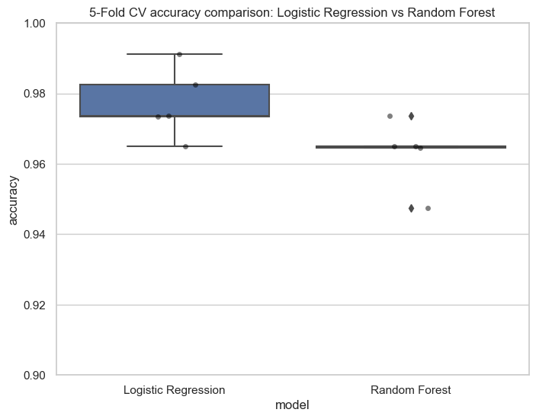
Logistic Regression consistently achieved higher scores, while Random Forest showed slightly lower but more tightly grouped results.
6.2 Overall Performance Summary
- Logistic Regression: mean = 0.9771, std = 0.0100
- Random Forest: mean = 0.9631, std = 0.0096
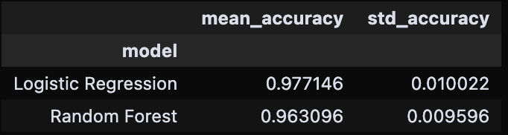
Interpretation
- Logistic Regression outperforms Random Forest by ~1.4%
- Both models show similar stability
- The dataset appears linearly separable, making a simpler model sufficient.
This is an interesting result because Random Forest is typically regarded as a strong out-of-the-box classifier (Breiman, 2001). Here, however, the breast cancer features are already relatively well-behaved and linearly separable after standardisation, so a simpler linear model is enough to capture the signal. The Random Forest adds non-linear capacity that does not translate into a performance advantage, but it still performs very well, above 96% accuracy.

7. Key Takeaways and Insights
7.1 Limitations of Single Splits
Single train–test splits can produce misleading results. Depending on the split, the same model may appear nearly perfect or only moderately effective.
7.2 Advantages of Cross-Validation
Cross-validation provides:
- A more reliable average performance estimate
- A measure of variability, improving interpretability
- Reduced dependence on a single random split
It effectively smooths out extreme results and gives a balanced evaluation.
7.3 Fair Model Evaluation
Using identical folds ensures that models are compared under the same conditions. This eliminates randomness as a confounding factor and leads to more trustworthy conclusions.

8. Limitations and Possible Extensions
No experiment is perfect, and this tutorial has some limitations:
- Single performance metric. I used accuracy only. For medical applications, metrics such as sensitivity, specificity, ROC-AUC and precision–recall curves are often more informative, especially when the costs of false positives and false negatives differ (Fawcett, 2006).
- Hyperparameters kept simple. I used a relatively standard Logistic Regression and a moderately sized Random Forest. A more exhaustive hyperparameter search nested inside the cross-validation loop could slightly change the ranking of the models.
- Only one dataset. The Breast Cancer Wisconsin dataset is clean and relatively low-dimensional. On high-dimensional or noisy data, the behaviour of cross-validation (and the relative strengths of the models) might differ.
- Randomness in shuffling. Although I fixed random_state for reproducibility, different seeds might slightly change the individual fold accuracies. However, the overall pattern is unlikely to change dramatically, especially with 5-fold CV.
Possible Extensions
- Use Stratified K-Fold
- Implement nested cross-validation for tuning
- Test on imbalanced or high-dimensional datasets

9. Conclusion
This tutorial demonstrated the importance of cross-validation using a real dataset:
- Single splits produced results between 95.6% and 100%, showing instability
- 5-Fold CV provided a more consistent estimate (~97.7%)
- Changing K had minimal effect on mean accuracy but influenced variability
- Logistic Regression outperformed Random Forest under consistent evaluation
Overall, cross-validation transforms evaluation from a single uncertain number into a more robust and informative assessment of model performance

References
Breiman, L. (2001) ‘Random Forests’, Machine Learning, 45(1), pp. 5–32.
Bishop, C.M. (2006) Pattern Recognition and Machine Learning. New York: Springer.
Fawcett, T. (2006) ‘An introduction to ROC analysis’, Pattern Recognition Letters, 27(8), pp. 861–874.
Hastie, T., Tibshirani, R. and Friedman, J. (2009) The Elements of Statistical Learning: Data Mining, Inference, and Prediction. 2nd edn. New York: Springer.
Kohavi, R. (1995) ‘A Study of Cross-Validation and Bootstrap for Accuracy Estimation and Model Selection’, in Proceedings of the 14th International Joint Conference on Artificial Intelligence (IJCAI), pp. 1137–1143.
Street, W.N., Wolberg, W.H. and Mangasarian, O.L. (1993) ‘Nuclear feature extraction for breast tumor diagnosis’, in Biomedical Image Processing and Biomedical Visualization, 1905, pp. 861–870.

